Front End Engineering-II

Project Report

Semester-IV (Batch-2022)

**DIGITAL AND ANALOG CLOCK**



**SupervisedBy: Submitted By:**

Dr. Raveesh Samkaria Rudrakshi, 2210990747 (G-12)

Department of Computer Science and Engineering

Chitkara University Institute of Engineering &Technology,

ChitkaraUniversity,Punjab

Abstract

This project develops a dual clock system with digital and analog clock components using HTML, CSS with the Tailwind framework, and JavaScript. The digital clock displays the current time, updated every second via JavaScript. The analog clock features hour, minute, and second hands dynamically positioned based on the current time. Tailwind CSS provides a modern, responsive design across devices. The clocks can integrate into web apps or function as standalone components. The project offers practical experience with web technologies, time manipulation, DOM manipulation, and building interactive, visually appealing components.

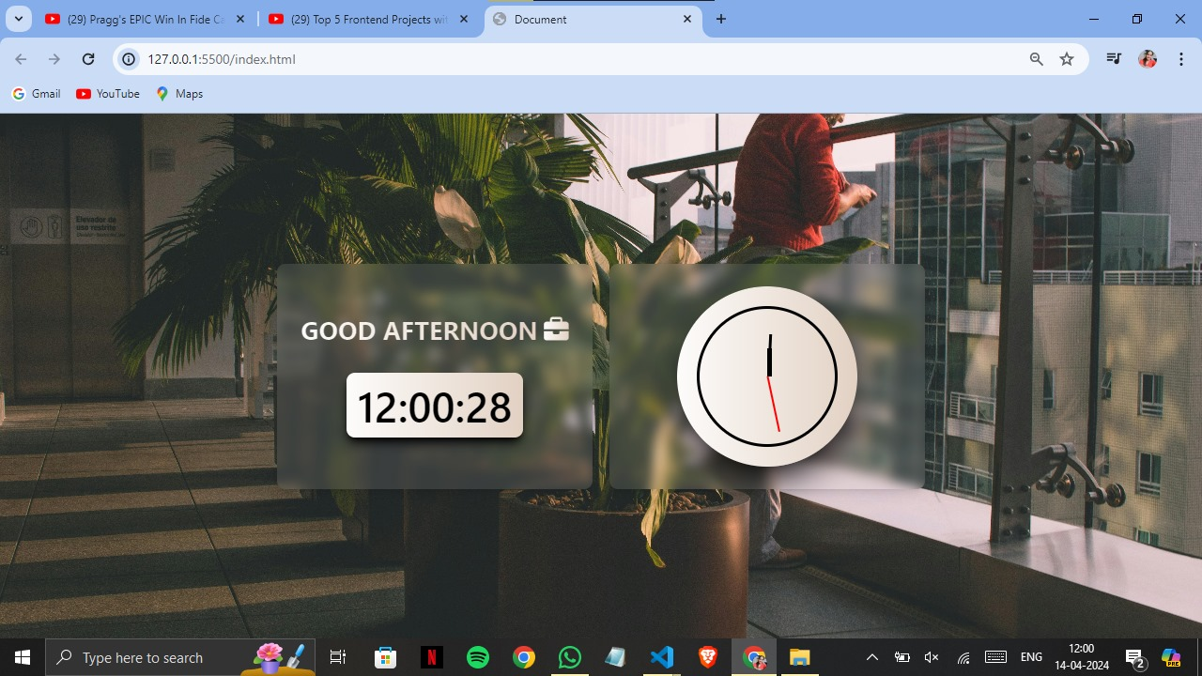

INDEX

|  |  |  |
| --- | --- | --- |
| S.No. | Title | Page Number(s) |
| 1 | Introduction | 4 |
| 2 | Problem Statement | 5 |
| 3 | Software Requirements | 5,6 |
| 4 | Proposed Design | 7-14 |
| 5 | Results | 15-18 |
| 6 | References | 19 |

1. Introduction

In the digital age, clocks have become an integral part of our daily lives, serving as a constant reminder of the passage of time. While digital clocks have gained widespread popularity due to their precision and ease of reading, analog clocks continue to hold a special place in our hearts, often associated with a sense of nostalgia and traditional timekeeping. This project aims to create a comprehensive solution that combines the best of both worlds, offering users a seamless experience with both digital and analog clock representations.

* 1. Background:

The concept of telling time has evolved significantly over the centuries, from sundials and water clocks to mechanical and electronic timepieces. With the advent of modern technology, digital clocks have become ubiquitous, offering a clear and precise display of time. However, analog clocks, with their elegant design and intricate movements, have remained a beloved choice for many individuals, adding a touch of sophistication and artistry to timekeeping.

* 1. Objectives:

The core goals of this project involve developing a functional and visually appealing implementation of both digital and analog clocks using web technologies. It leverages HTML for structuring the clock components, CSS with the Tailwind framework for styling, and JavaScript for dynamic updates and interactivity. Furthermore, the project aims to ensure the clocks are responsive and display correctly across various devices and screen sizes and create a modular and reusable codebase that can be easily integrated into web applications or used as standalone components.

* 1. Significance:

The project holds significant value as it provides a practical exercise in building interactive and visually appealing web components, combining digital and analog time representations. It offers hands-on experience with HTML, CSS (including Tailwind framework), and JavaScript, reinforcing essential web development skills. Additionally, it explores concepts like time manipulation, DOM manipulation, and event handling

1. Problem Statement

In the digital age, while digital clocks have become ubiquitous due to their precision and ease of reading, there is still a demand for analog clocks, which offer a traditional and aesthetically pleasing way of representing time. However, developing a solution that seamlessly integrates both digital and analog clocks, while ensuring responsiveness across multiple devices and providing additional features, can be a challenging task.

1. Software Requirements
2. Integrated Development Environment (IDE):

* Visual Studio Code (VS Code) will be utilized as the primary code editor and project management tool for its robust features, extensive extension ecosystem, and efficient workflow.

1. Technology Requirements:

* HTML5 (Hypertext Markup Language) will be employed for structuring the web application and creating the necessary elements for the clock components and user interface.
* CSS3 (Cascading Style Sheets) will be used for styling the application, ensuring a visually appealing and coherent design across different components and screen sizes.
* JavaScript (ES6+) will be the programming language of choice for implementing interactive features, dynamic updates, time calculations, and handling user interactions within the application.

1. Utility-first CSS Framework:

* Tailwind CSS, a highly customizable and utility-first CSS framework, will be leveraged to streamline the styling process and achieve a modern, responsive design with minimal effort.

1. Version Control and Collaboration:

* Git, a distributed version control system, will be utilized for tracking changes in the project codebase, enabling efficient collaboration, and facilitating code reviews and merges.
* The project repository will be hosted on GitHub, a popular platform for code hosting, collaboration, and issue tracking.

1. Browser Compatibility and Performance:

* The application will be developed with a focus on cross-browser compatibility, ensuring it functions correctly and consistently across the latest versions of popular web browsers.
* Performance optimization techniques will be implemented to ensure smooth and efficient rendering, minimizing resource consumption and providing an optimal user experience.

1. Proposed Design

User Interface:

* The application will feature a responsive and visually appealing layout using Bootstrap 5, ensuring a consistent experience across various devices and screen sizes.
* A card-based design will be employed to organize the different components of the application, such as the digital clock, analog clock, and time format/date display options, in an intuitive and user-friendly manner.

Development Technologies:

* HTML5 semantic elements will be utilized for structuring the application, ensuring proper semantics and accessibility.
* CSS will be responsible for styling the application, creating a visually appealing and cohesive design.
* JavaScript will be used for implementing dynamic UI updates, handling user interactions, and managing the clock logic and time calculations.

User Experience:

* Real-time feedback and interactive elements, such as smooth animations and transitions, will be implemented to create an engaging and responsive user interface.
* Cross-browser compatibility will be a priority, ensuring the application functions consistently across the latest versions of popular web browsers.
* Responsiveness will be a key focus, with the application designed to adapt seamlessly to different devices and screen sizes, providing an optimal user experience on both desktop and mobile platforms.

Testing and Quality Assurance:

* Comprehensive testing, including manual and unit tests, will be conducted to ensure the application's functionality and user interface consistency.

Documentation and Deployment:

* Detailed documentation, including installation instructions, usage guidelines, and relevant information for developers and users, will be provided.
* The application will be deployed on a web server with a domain, ensuring accessibility and ease of use for end-users.

Dynamic Background:

* The background image of the application will change dynamically based on the current time, creating a visually appealing and immersive experience for the user.
* Different background images will be associated with specific time periods, such as morning, afternoon, evening, and night, to create a seamless and cohesive design.
  1. File Structure

Establishing a meticulous organization of files and folders to uphold uniform file paths and a

clutter-free arrangement.

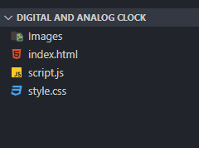

* 1. HTML Code Structure

The provided screenshots showcase the HTML code for our Digital and Analog Clock project, depicting the layout and content of our web pages in code format.

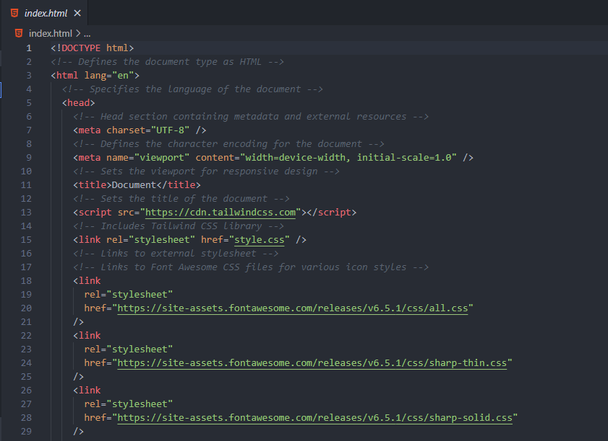

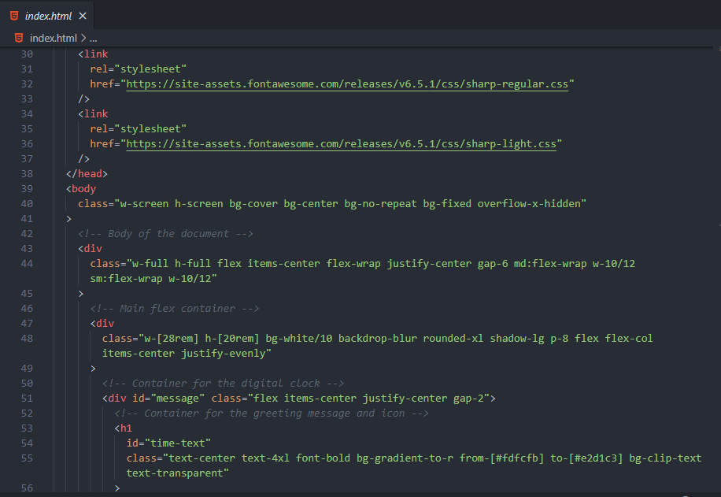

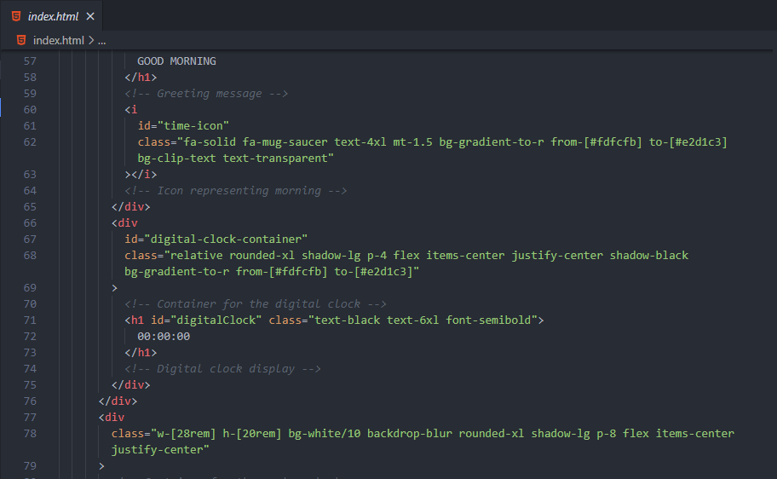

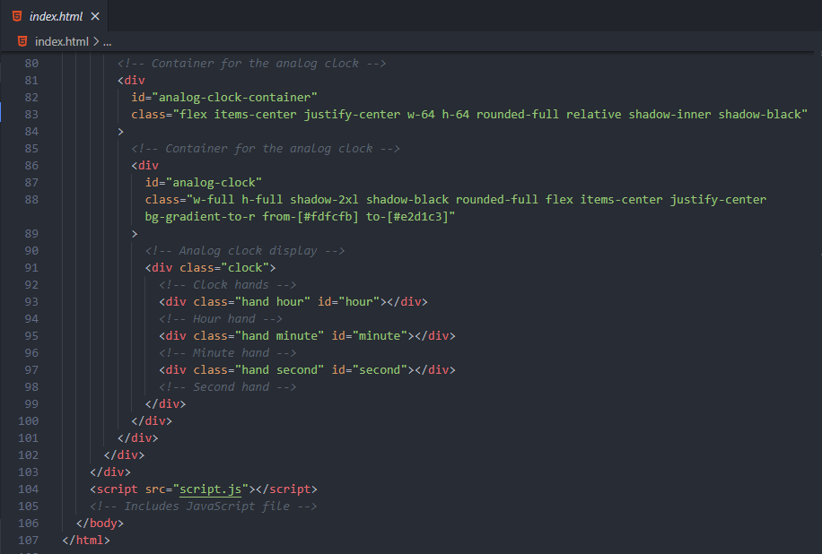

* 1. CSS Code Structure

The screenshots exhibit the CSS code for our Digital and Analog Clock project, demonstrating the styling and visual presentation of our web pages in code format.

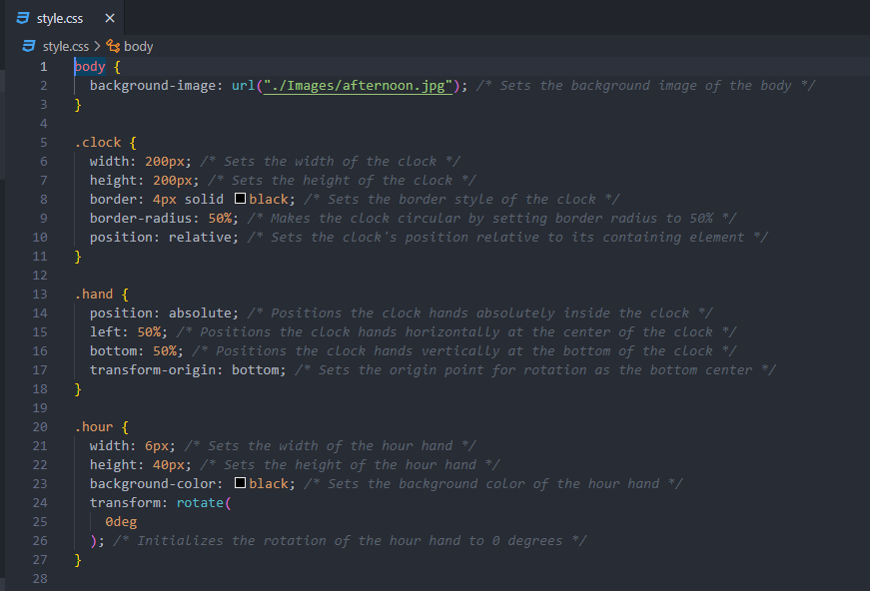

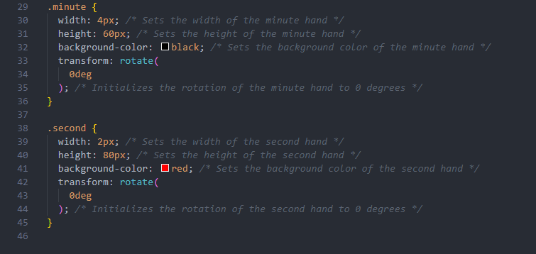

* 1. Javascript Code Structure

The screenshots depict the JavaScript code for our Digital and Analog Clock project,

showcasing the interactive features and dynamic functionalities of our web pages in code

format.

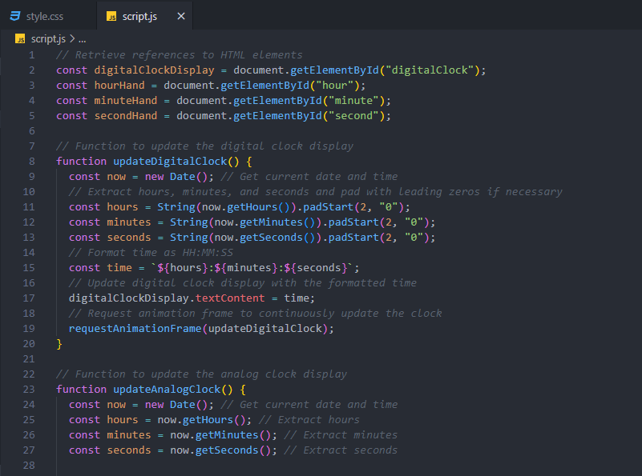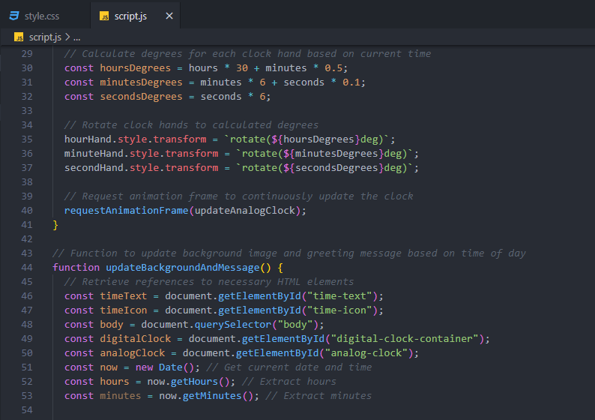

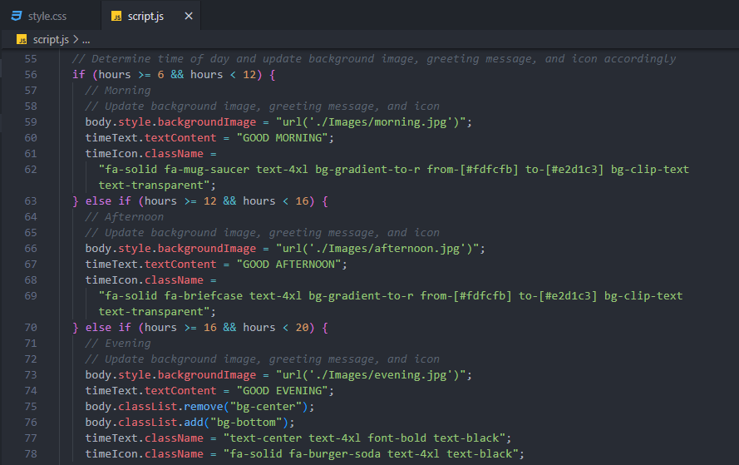

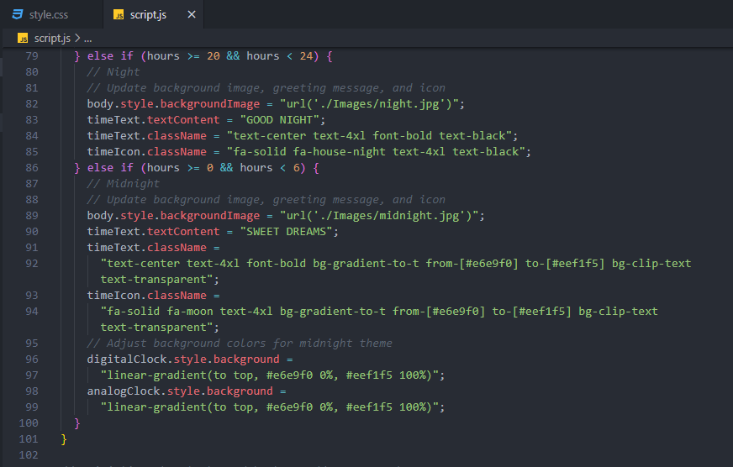

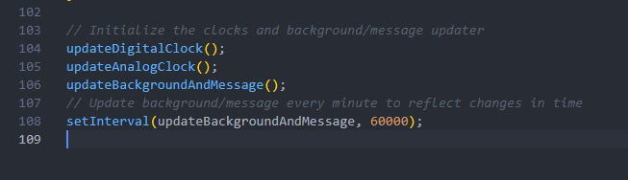

1. Results

The displayed results showcase the synchronized digital and analog clocks, alongside dynamically changing background images and greeting messages based on the current time. Through rigorous testing and user feedback, the following key outcomes have been achieved:

Git Hub Repository Link:

Git Hub Pages Link:

These screenshots capture different instances of my project, showcasing its appearance and functionality at various points in time.

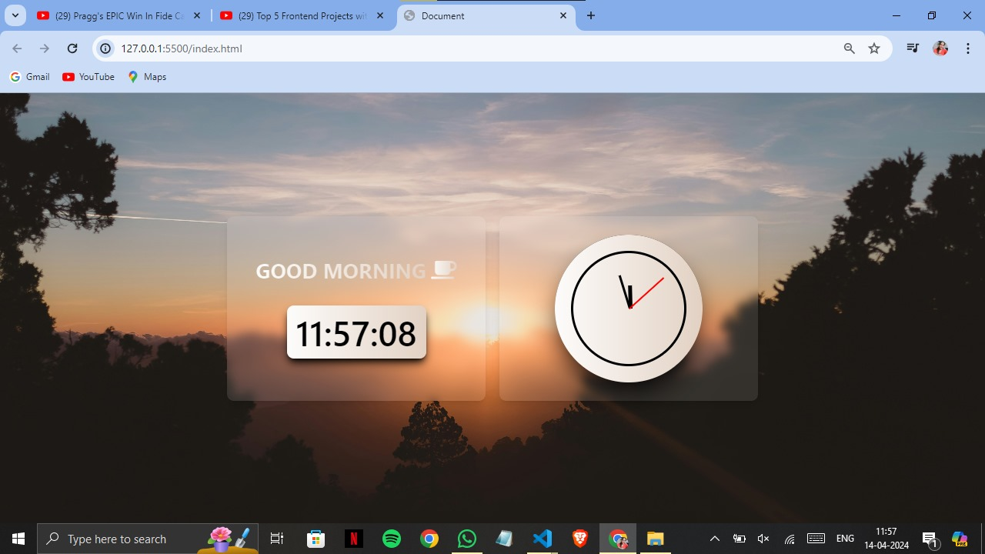

Morning Ambiance



Afternoon Serenity

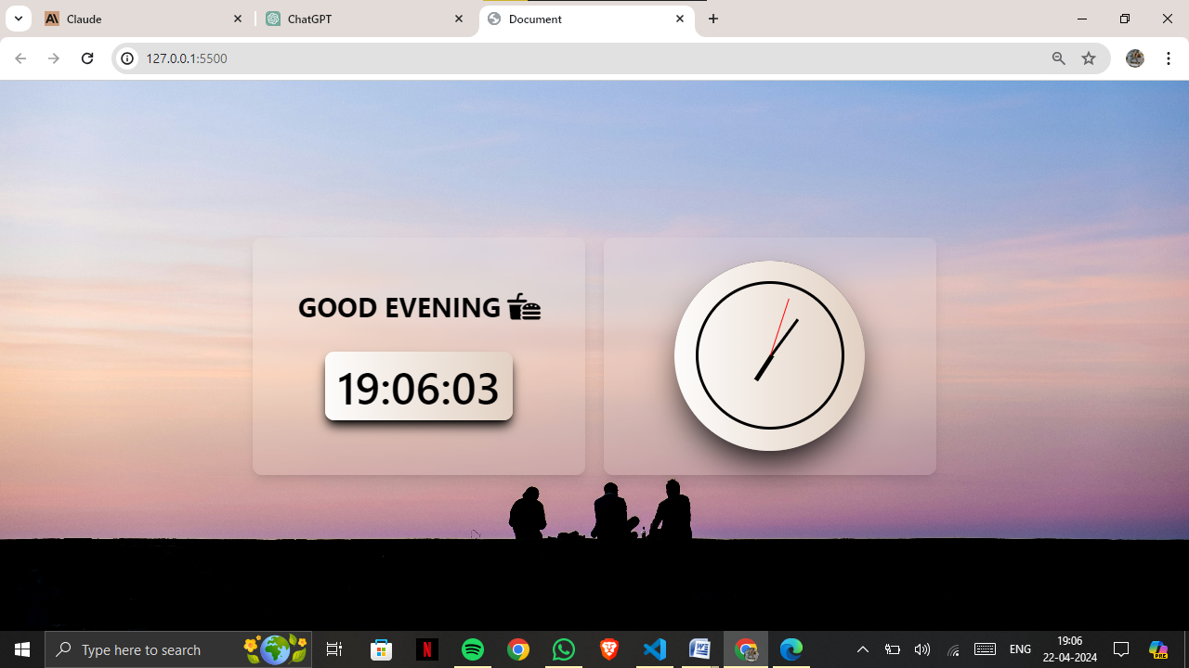

Evening Tranquility

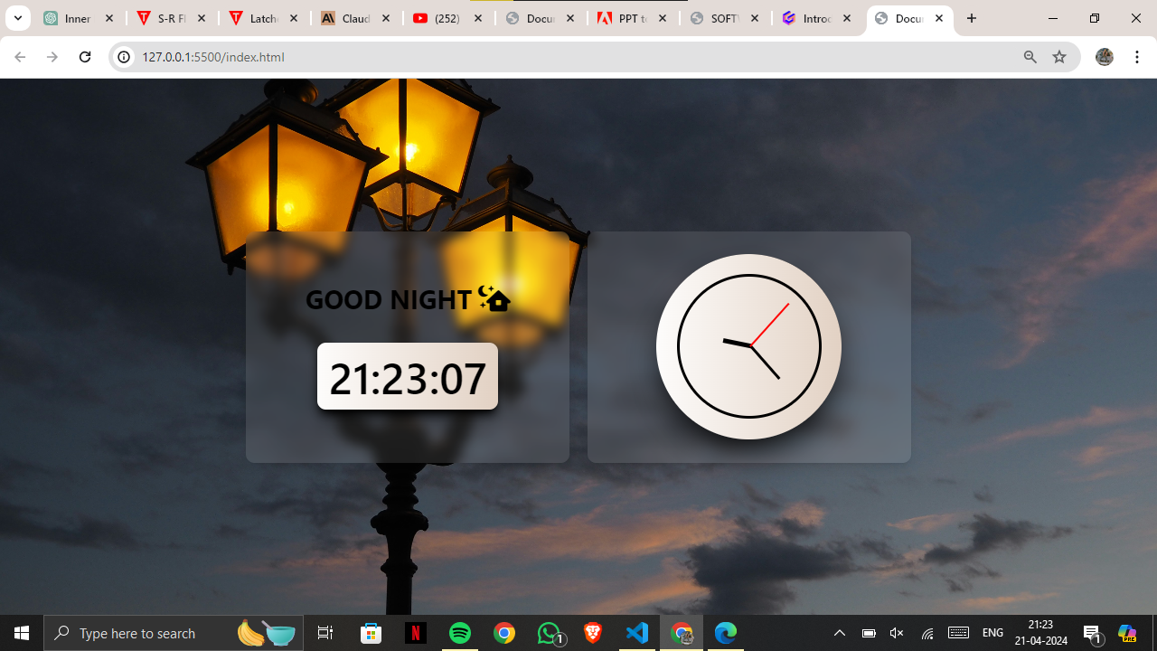

Nighttime Stillness

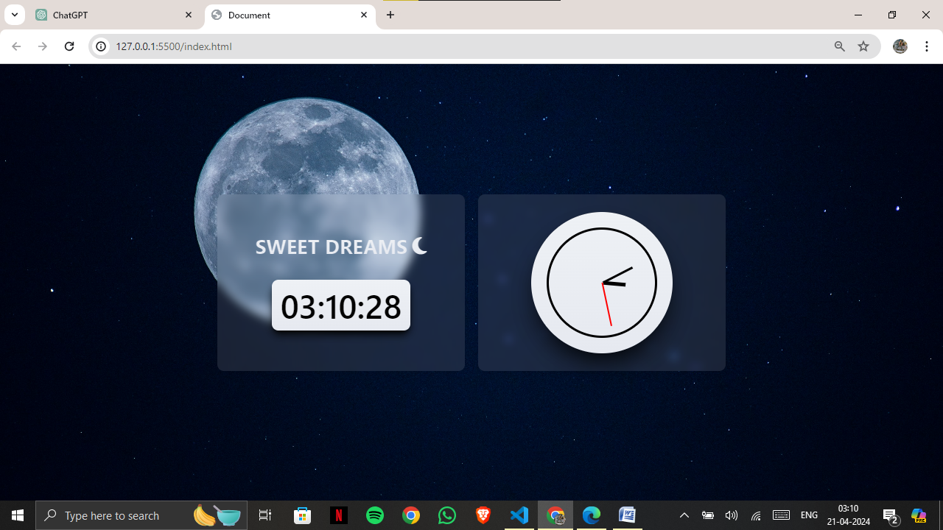

Midnight Mystery

* Our project focuses on digital and analog clocks, presenting accurate time
* Utilizing HTML, CSS, Tailwind, and JavaScript, we've crafted a seamless and visually appealing time-telling interface.
* JavaScript ensures synchronization between the digital and analog clocks, offering precise timekeeping.
* A standout feature of our project is its adaptability—the background image changes dynamically to reflect the time of day.
* Whether it's the serene glow of morning, the warm hues of afternoon, the calming twilight of evening, the tranquil darkness of night, or the enigmatic ambiance of midnight, our project adjusts the background image accordingly.
* Through this integration of technology and design, our project offers both functionality and aesthetic appeal, enhancing the user experience with each passing hour.

1. References
   * Mozilla Developer Network (MDN) - HTML, CSS, JavaScript Documentation:

* Website: https://developer.mozilla.org/
* Description: MDN offers comprehensive documentation on HTML, CSS, and JavaScript, covering everything from basic syntax to advanced concepts and APIs.
  + W3Schools - HTML, CSS, JavaScript Tutorials:
* Website: https://www.w3schools.com/
* Description: W3Schools provides beginner-friendly tutorials and references for HTML, CSS, and JavaScript, along with interactive code examples.
  + Tailwind CSS Documentation:
* Website: https://tailwindcss.com/docs
* Description: The official Tailwind CSS documentation provides detailed guidance on using Tailwind CSS for building modern and responsive web interfaces. It includes utility classes, customization options, and best practices.
  + CSS-Tricks:
* Website: https://css-tricks.com/
* Description: CSS-Tricks is a web design community that offers articles, tutorials, and resources related to CSS, HTML, and frontend development. It covers a wide range of topics, including layout techniques, CSS animations, and frontend frameworks.
  + Smashing Magazine:
* Website: https://www.smashingmagazine.com/
* Description: Smashing Magazine publishes articles, tutorials, and case studies on web design and development, including frontend technologies like HTML, CSS, JavaScript, and modern frameworks like Tailwind CSS. It also features interviews with industry experts and showcases of cutting-edge web projects.